Diamond Shop Project

# **1. Introduction**

## **1.1 Purpose**

* The objective of Diamond is to create a reputable and convenient online platform where users can buy and sell diamonds, diamond jewelry, and other gemstones. The system will offer a premium online shopping experience with detailed product information, high-quality images, and excellent customer service.

## **1.2 Scope**

* The scope of the Diamond Haven website includes the design, development, deployment, and maintenance of an online platform for buying and selling diamonds and diamond jewelry. The system is intended to provide a seamless and secure shopping experience for customers while offering robust administrative functionalities for managing the website.

# **2. UI**

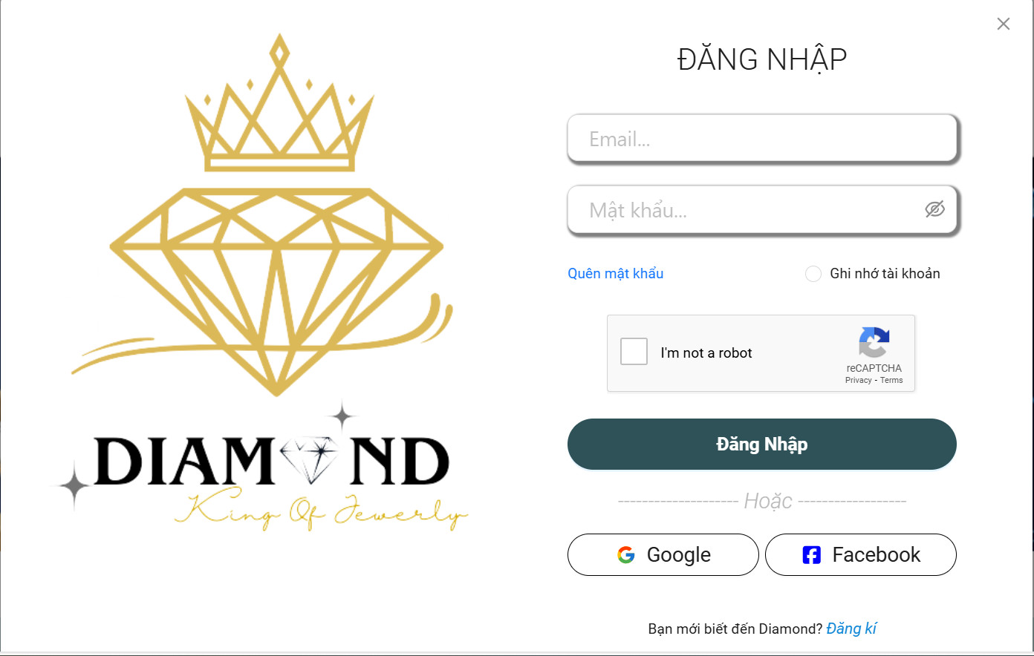

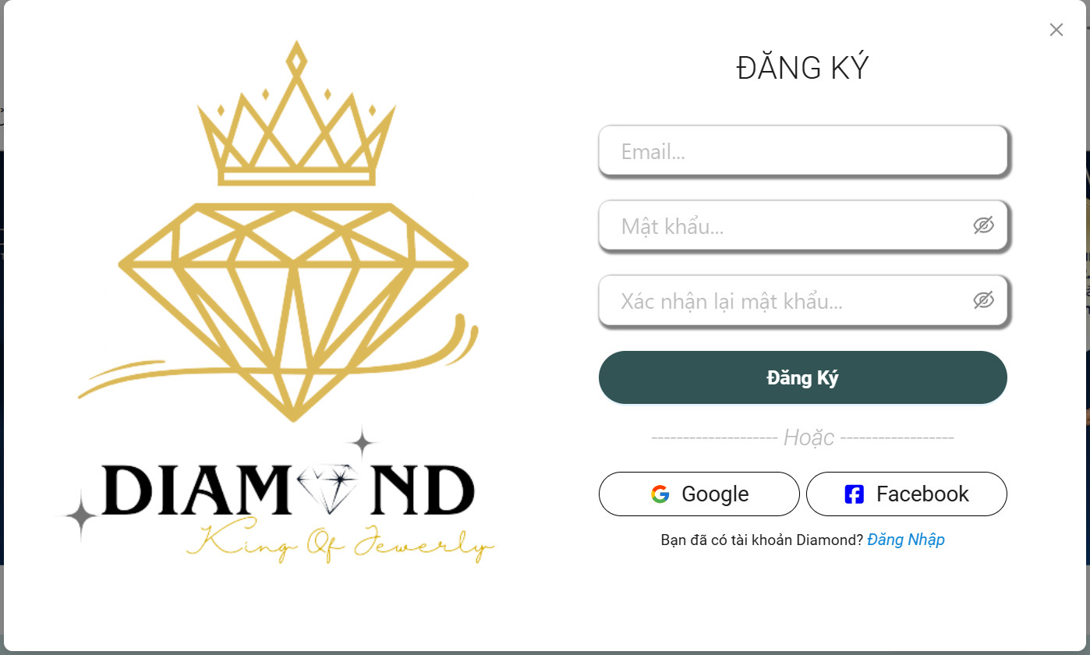

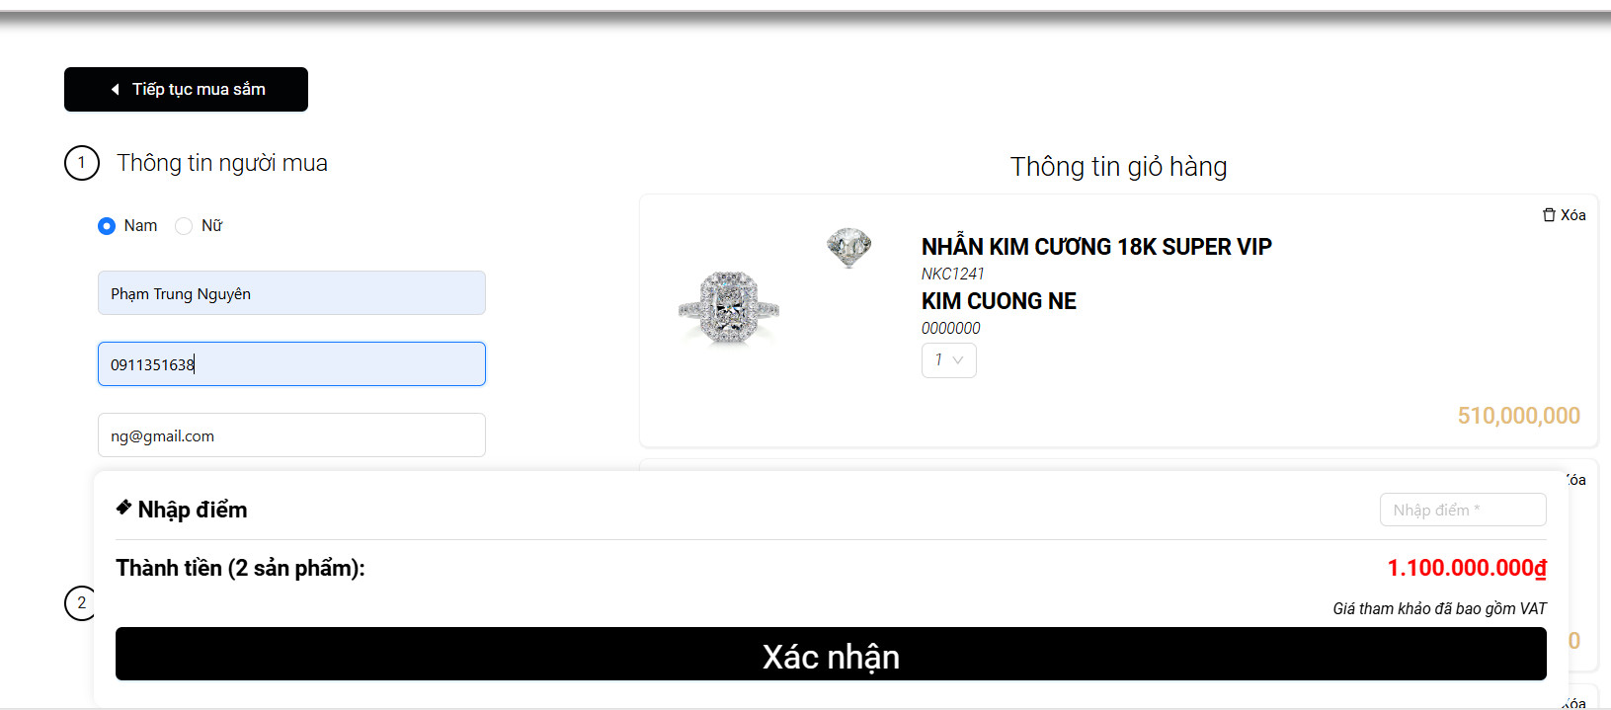

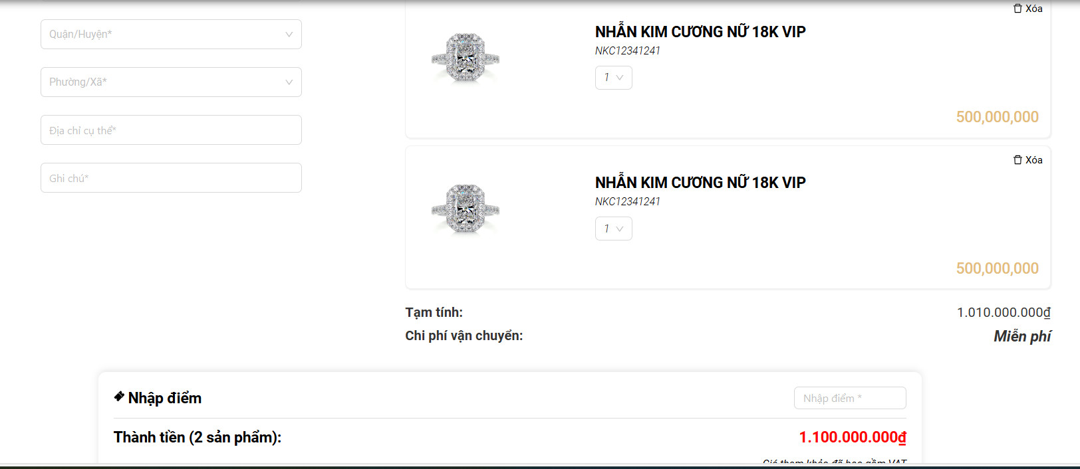

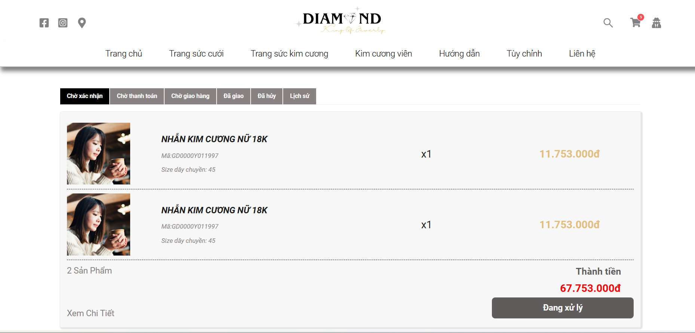

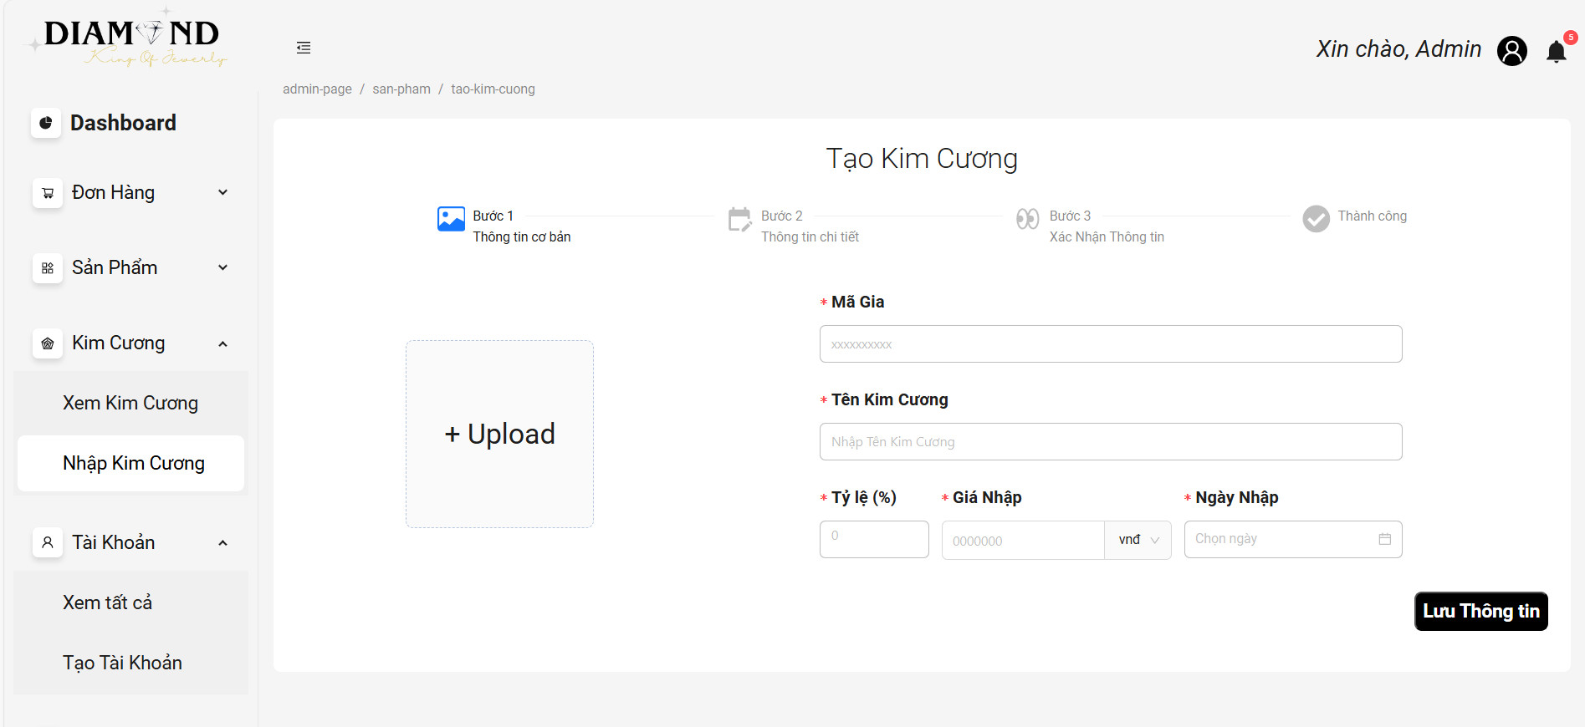

# **3. ERD**

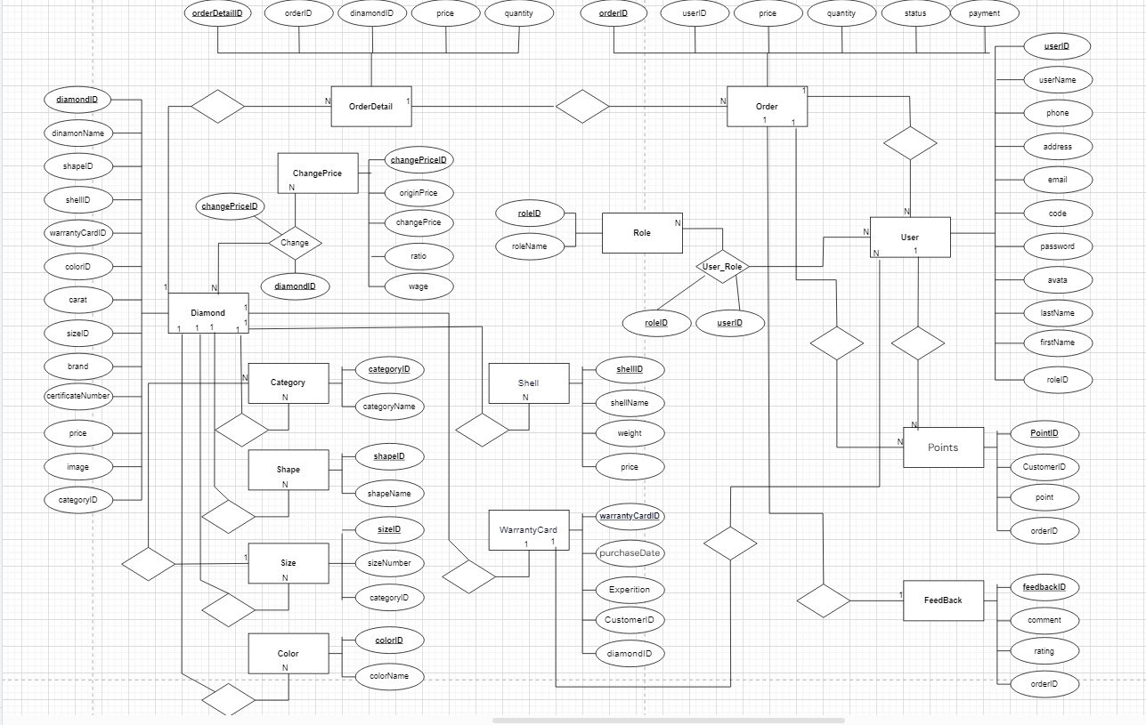

## **4. Technical Requirements (TRD)**

## **1. Guest**

## 

## View Home Page:

## 

## Display products and product information without requiring login.

## Search:

## 

## Allows searching products by keywords.

## Cart:

## 

## Allows adding, deleting and editing carts.

## Pay:

## 

## Provide payment methods for customers.

## **2. Customers**

## 

## Register:

## 

## Allow customers to register for an account.

## Login, Logout:

## 

## Provides login and logout functionality.

## View and Update Profile:

## 

## Allows customers to view and update profile information.

## View Home Page and Search:

## 

## Display products and allow product searches.

## Manage Shopping Cart:

## 

## Allows adding, deleting and editing carts.

## Pay:

## 

## Provides secure payment methods.

## **3. Sales Staff**

## 

## Order Management:

## 

## View, accept and cancel orders.

## Create Warranty Card:

## 

## Create a warranty card for your order.

## Payment confirmation:

## 

## Confirm payment related to the order.

## Reply Feedback:

## 

## Respond to feedback and questions from customers.

## **4. Delivery Staff**

## 

## Receive purchase order:

## 

## Get information and details about your order.

## Delivery Update:

## 

## Update delivery status and provide shipping information.

## **5. Manager**

## 

## Dashboard:

## 

## See overview and statistics about system performance.

## Product Management:

## 

## Add, edit, delete products.

## Employee manager:

## 

## Add, edit, delete employee accounts.

## Order Management:

## 

## View, accept, delete orders.

## **6. Administrator (Admin)**

## 

## Dashboard:

## 

## See overview and statistics about system performance.

## Product Management:

## 

## Add, edit, delete products.

## Employee manager:

## 

## Add, edit, delete employee accounts.

## Order Management:

## 

## View, accept, delete orders.

## Manager Management:

## 

## Add, edit, delete management accounts.

## 